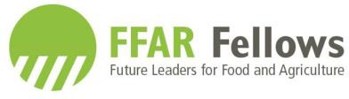
Call for a Host Institution for the Second Residential Session for the FFAR Fellows Program
Due February 1, 2019.

The Foundation for Food and Agriculture (FFAR) Fellowship Program was established to provide professional development and career guidance to the next generation of food and agriculture scientists across FFAR’s seven Challenge Areas and strategic initiatives. The consensus among employers is that U.S. universities could better prepare a career ready STEM workforce by breaking down the disciplinary siloes and increasing the focus on professional development and “soft-skills”, which would result in more well-rounded graduates. By providing early career support to graduate students, the Fellowship cultivates supportive relationships between graduate students and industry peers to equip students with the skills needed to facilitate their transition to the workforce and prepare future leaders for food and agriculture.
Fellows are co-mentored over the 3-year program by university and industry representatives and engage with their peers in professional development programming both virtually and at the annual one-week residential sessions. Three cohorts with a minimum of 16 and maximum of 20 students will be recruited in 2018, 2019, and 2020.
The flagship component of the FFAR Fellowship is the annual Residential Session. These sessions focus on non-technical training in soft skills and people skills, with some of this training occurring in industry partner facilities alongside private sector research scientists. Each week is designed to build on the prior sessions and to advance student non-technical skills and knowledge (Figures 1 and 2).

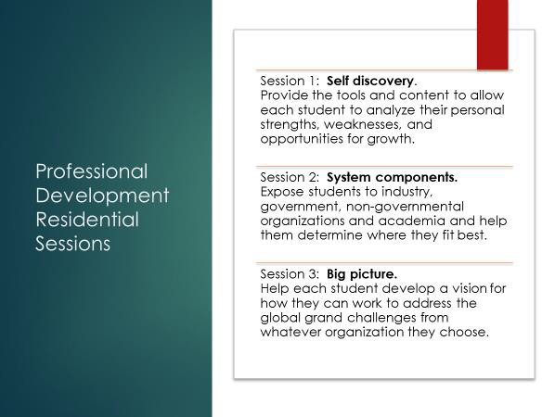
Figure 1. Annual Residential Session Objectives, FFAR Fellows Program

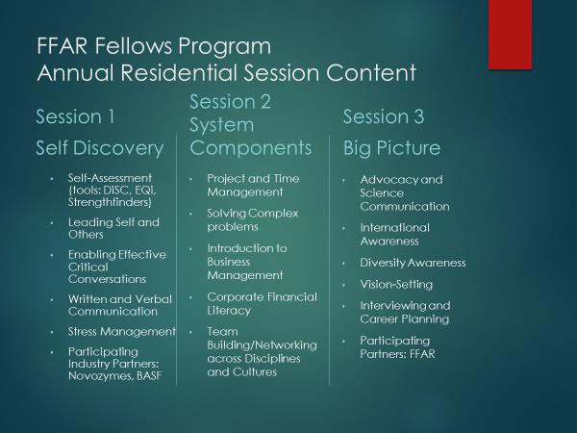
Figure 2. Professional Development Content per Residential Session, FFAR Fellows Program

As the lead institution for the FFAR Fellows Program, North Carolina State University hosts the first residential session for each of the three cohorts. The first cohort of fellows was in residence at NC State August 5 – 9, 2018.
The FFAR Fellows Program is seeking a host institution for the second session. The selected university will have the option of hosting the second session for all three cohorts of fellows—in 2019, 2020, and 2021. The session should span five nights in residence, and occur within the following time window: May 17 and May 29, 2020. While the first session largely focuses on the self, the second session should expose students to government and non-governmental organizations as well as industry. The third session, to be held in Washington, D.C., will be hosted by FFAR and will focus on advocacy and vision-setting. All sessions include instruction and activities to build professional development skills.
The host will be responsible for co-designing the session in collaboration with the Director of the FFAR Fellows Program, and covering all costs associated with the session, including student lodging, meals, and transport to and from the airport; and speaker travel and fees. Costs will be covered using funds from a $36,000 subaward from NC State University. This subaward includes 10% for the sponsoring university’s overhead, and an expected cost of $7,000 for student travel (8 students cover their own travel; 8 students have their travel to and from the residential session covered by the host institution).
Application Instructions: To apply to be a host for the second residential session, prepare a two to three-page proposal that serves as a draft for the event, including proposed training sites, training modules, industry partners, any site visits, and a proposed budget. Submit via email to the FFAR Program Director at rebecca_dunning@ncsu.edu by February 1, 2019. The selection of host institution will be made by March 15, 2019.
For questions, email or call Rebecca at 919.389.2220. For general information on the FFAR Fellows Program and an introduction to this year’s cohort of Fellows, see ffarfellows.org.

